MongoDB Lab2

1 - Download the following json file and import it into a collection named “zips” into “iti” database

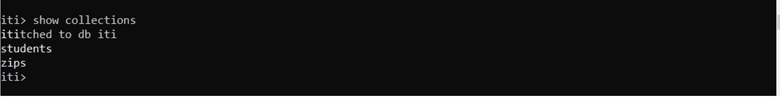

2 – find all documents which contains data related to “NY” state

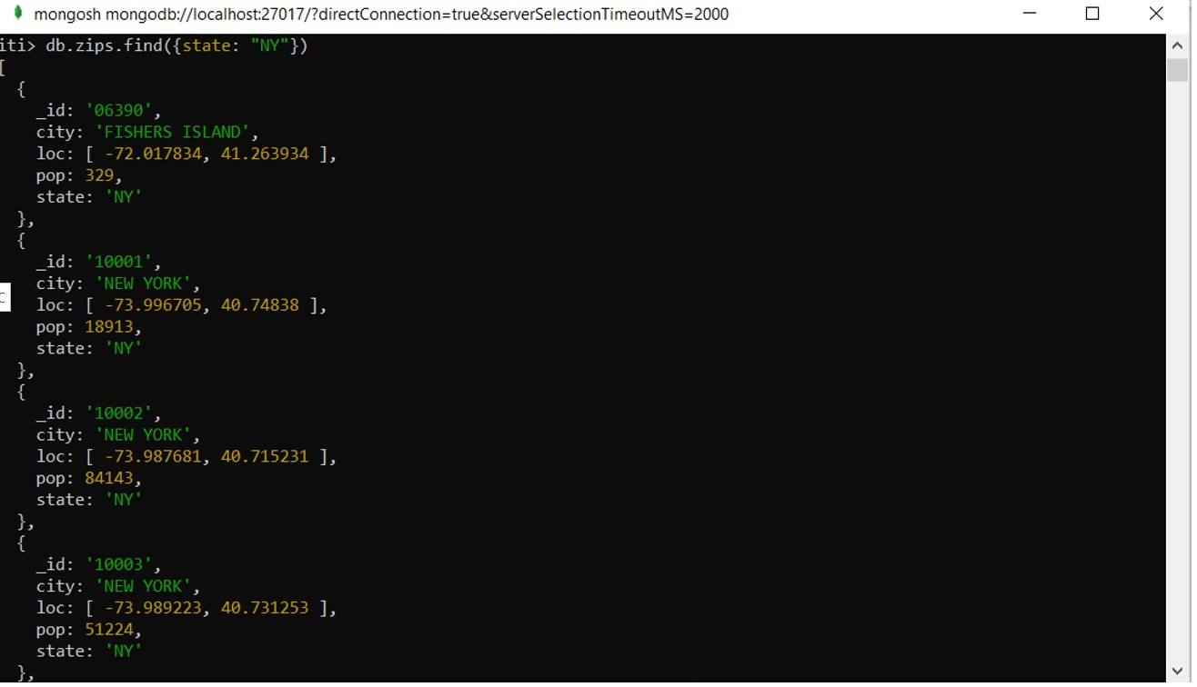

3 – find all zip codes whose population is greater than or equal to 1000
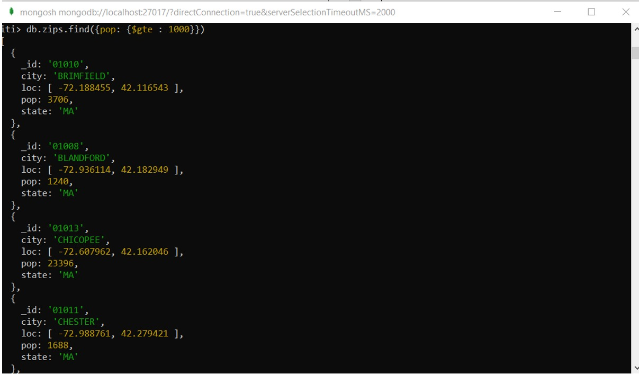
4 – add a new boolean field called “check” and set its value to true for “PA” and “VA” state
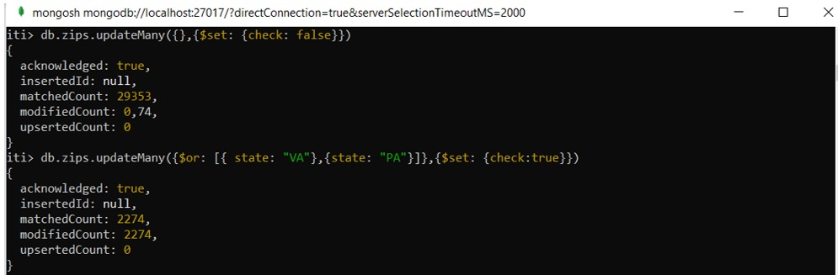
5 – using zip codes find all cities whose latitude is between 55 and 65 and show the population only.
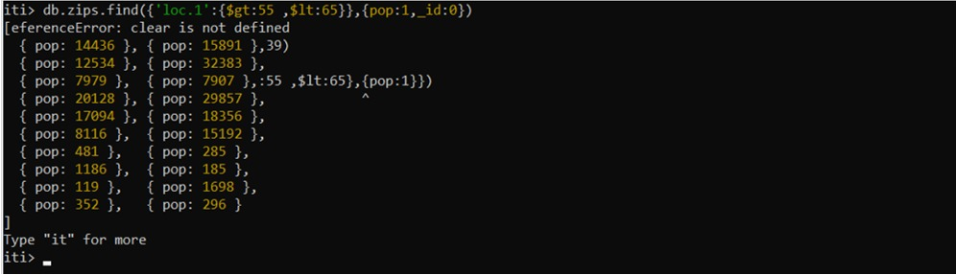
6 – create index for states to be able to select it quickly and check any query explain using the index only.
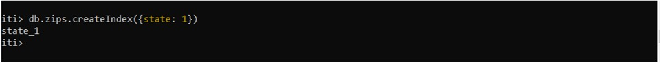

7 – increase the population by 0.2 for all cities which doesn't located in “AK” nor “NY”
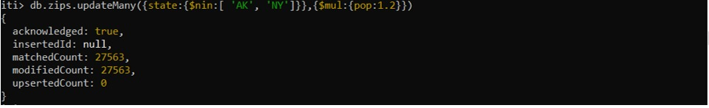

8 – update only one city whose longitude is lower than -71 and is not located in “MA” state, set its population to 0 if zipcode population less than 200.
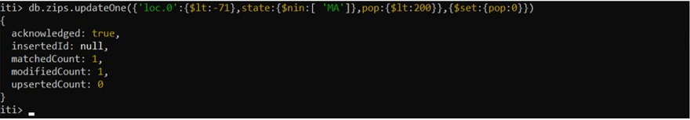

9 – update all documents whose city field is a string, rename its city field to be country and if there isn't any, add new document the same as the first documet in the database but change the _id to avoid duplications.
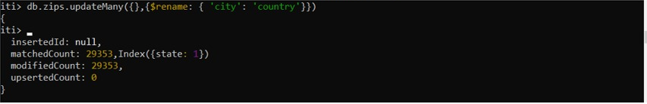

part2

- Get sum of population that state in PA, KA
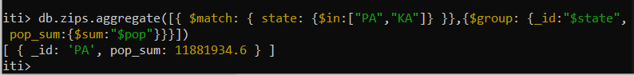

- Get only 5 documents that state not equal to PA, KA
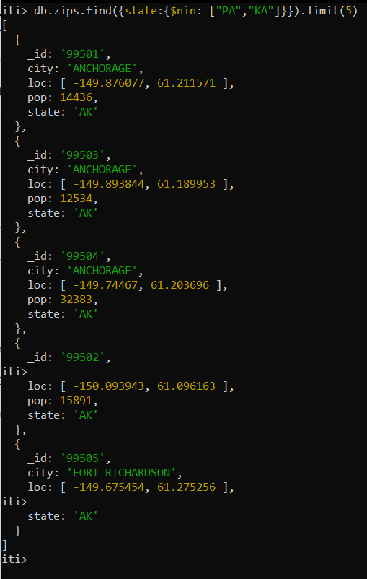

- Get sum of population that state equal to AK and their latitude between 55, 65

- Sort Population of document that state in AK, PA and skip first 7 document

- Get smallest population and greatest population of each state and save the result in collection named "mypop" on your machine colleague
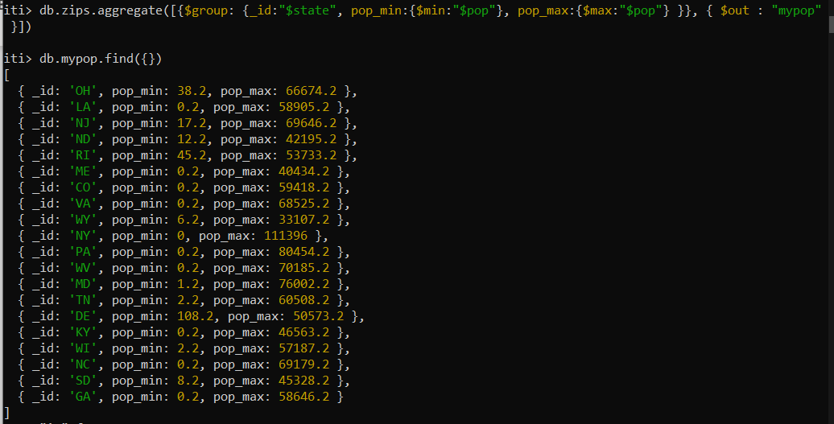

- Write an aggregation expression to calculate the average population of a zip code (postal code) by state
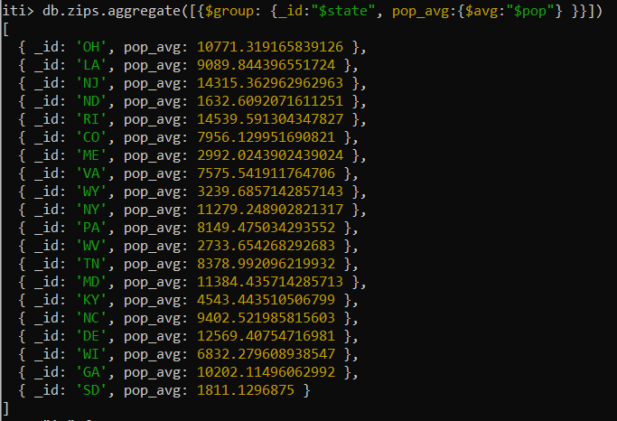

- Write an aggregation query with just a sort stage to sort by (state, city), both ascending
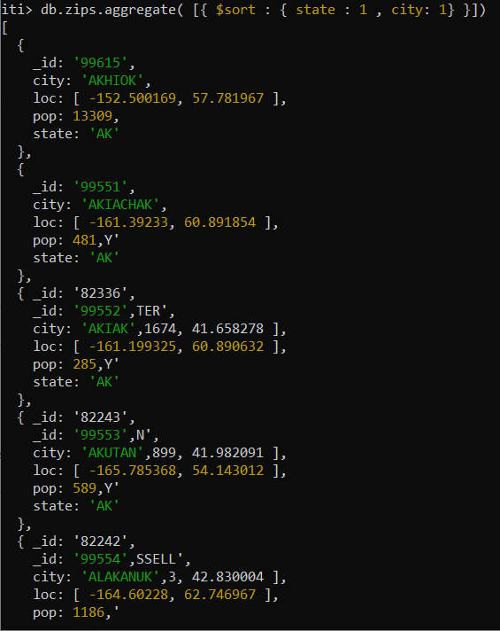

- Write an aggregation query with just a sort stage to sort by (state, city), both descending
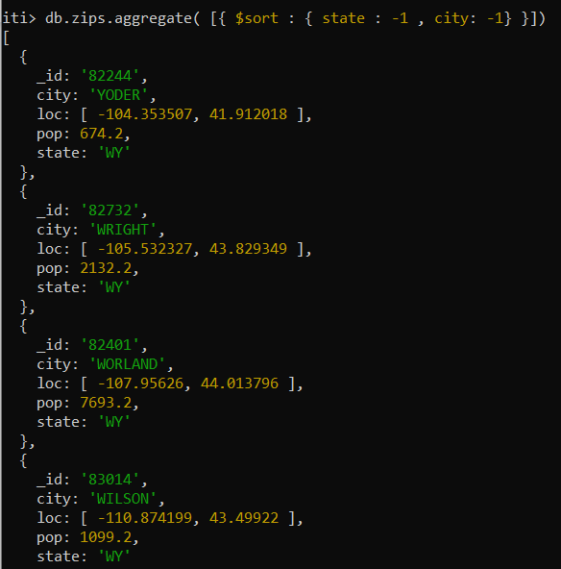

- Calculate the average population of cities in California (abbreviation CA) and New York (NY) (taken together) with populations over 25,000
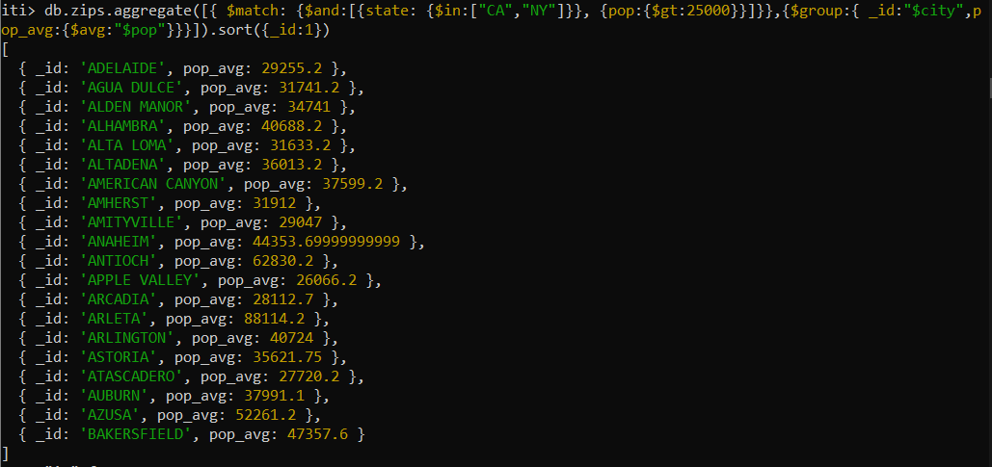
- Return the average populations for cities in each state
